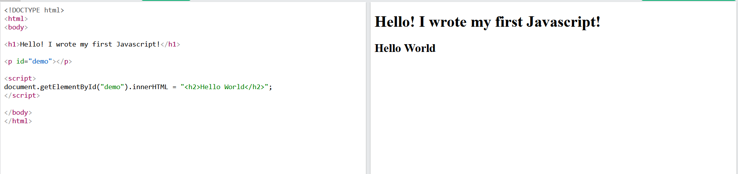
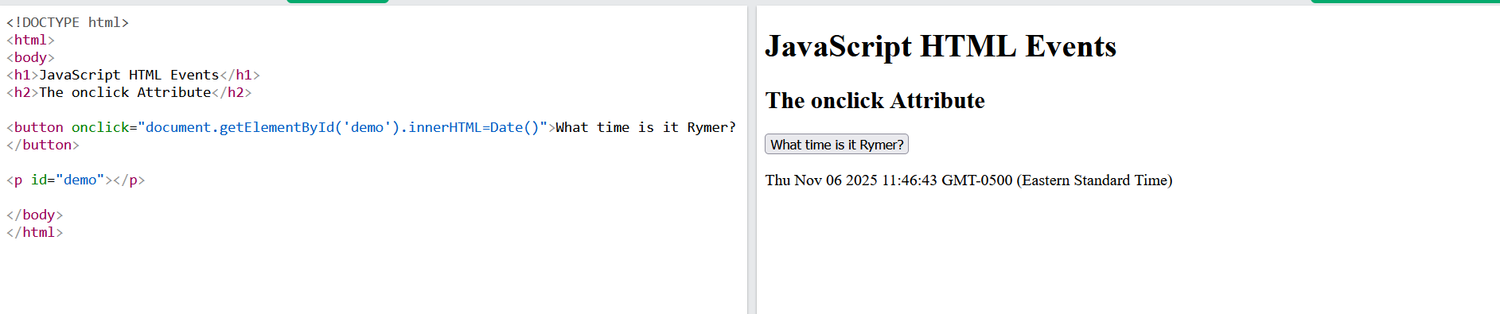

How is the code different?
- The code in the first script doesn’t contain a button while the second script does. The code in the second script also returns the date and time while there is no user interaction in the second script.
If-else which is best control structure?
- The if-else control structure consists of evaluating a condition and works well when only one condition needs to be checked. There is also the else-if statement which can check many different conditions. So the else if statement would be the best control structure since it is able to check many different conditions.

